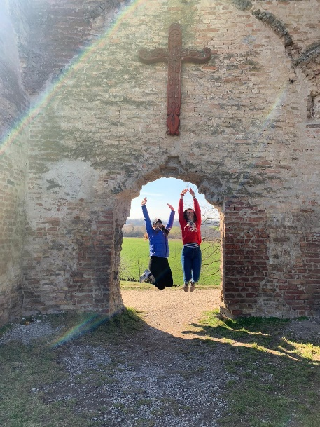
You might deem it very silly to choose to apply for an Erasmus scholarship amidst the world pandemic – and I do agree. It would have been a task even for a professional Buddhist to stay calm while organizing everything, as the rules were changing on a daily basis (not just in Hungary) and the whole Europe was a chaos. A week before my departure I was told to get a PCR test in order to be accommodated in the dorm, two days before my departure, Hungary closed its borders and I was told to get accommodation in a hotel and then upon my arrival it was all different again. When somebody asks me what Erasmus gave me, I tell them that it was the best lesson for stress management one could ever get (I cannot thank the coordinators enough though).
The „experience“ factor of Erasmus was diminished, as the school was closed most of the academic year and apart from two great months of events at the beginning, one could not do much. However, I still think it was better than if I sat the whole year in exactly the same situation and with the same possibilities at home. I regret nothing.
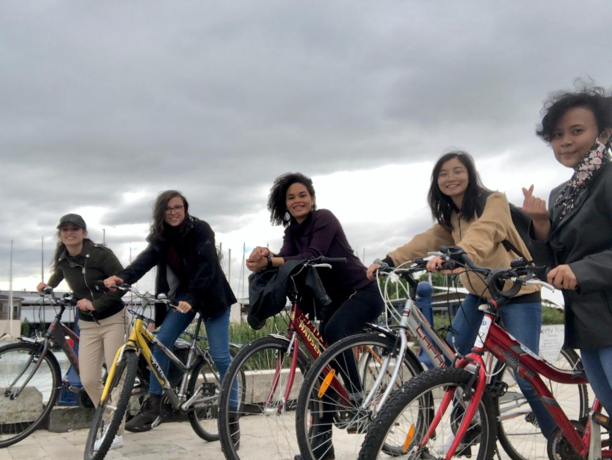
The academics were, let’s say, different. I am used to having a final exam from every subject, which was not the same in Debrecen. Because of that, I could really use my time to experience the place rather than have my head stuck in books.
The best part were definitely the people I met. Debrecen has a great advantage of being full of international students, so one does not feel like the only stranger. On the other hand, office staff is usually not eloquent in English, so when I tried to send a postcard home while only knowing the word “bélyeg”, it was a linguistic miracle on both sides that it got sent correctly.
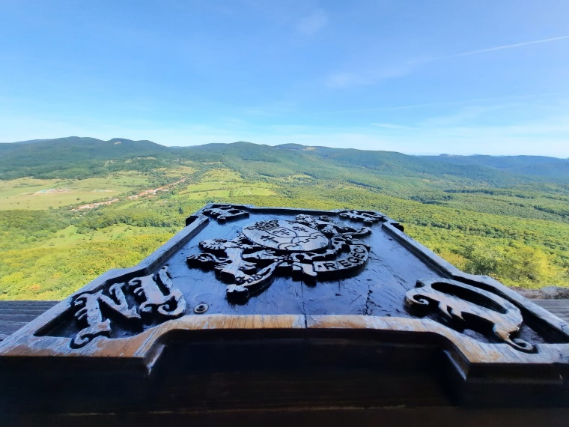
I am still in contact with my classmates and friends up to this day. I feel like having lived in a bubble (religious, cultural and social) which fell apart totally in Debrecen. I realized how different people were, how different priorities they had and how differently they looked at life. I am grateful for that (I remember my friends peeling apples because in their countries they are full of pesticides, while I was telling them they don’t have to worry about that at all). It was sad that the Hungarian students had to leave the dorm as I would have appreciated more Hungarian language around…
Another part that I am jealous of and loved totally, was the nearly-zero elevation throughout the city (and most of the country, too) which enabled me to go everywhere by bike and kept me active. I went by bike to Zelemér for example, a wonderful place right behind the city, or I travelled by train to the more distant places like Esztergom. The year went by really quickly, faster than you would spell “viszontlátásra”.

