Erasmus+ Experience Report
Kamilla Himinec
I am Kamilla Himinec, a third year horticulture student at the University of Debrecen. I studied at the BOKU University in Vienna for half a year, Master of Phytomedicine.
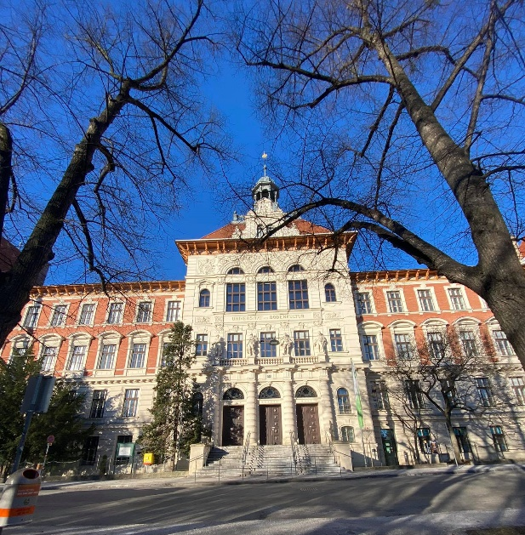
Why did I apply for Erasmus and why did I choose BOKU Vienna?
I spent a lot of time looking for a university, writing emails to lots of different coordinators out there, asking about courses. Even then I liked BOKU very much because all the information was available on their website, and this university gave me the opportunity to choose the subjects I was interested in. Furthermore, BOKU is among the best agricultural universities in the world.
Despite COVID, it was an experience of a lifetime, meeting people from many new cultures, travelling with my new Erasmus+ friends. There was a curfew from 1 April to 2 May, but we were able to walk around a lot and organise picnics with other Erasmus+ students. Before the curfew, however, we visited several museums and organised many activities with other Erasmus+ students. We had a hybrid education at university. Most of the lectures were held online, but the lab classes were on campus and you could also take part in the excursions for a negative test. In Austria we had the opportunity to get a free coronavirus test. It was possible to do a PCR test in 15 different districts, where I got the result in about 20 minutes. You can also do a Gurgel test. The way it works is that after registering at the BIPA shop here, you get a QR code to take 4 tests. We did these at home, took them the next morning and had the results by the end of the day. I have taken both types of tests several times in class. Sometimes they also test right before class on campus, so we were able to take attendance courses safely.
BOKU has 3 different campuses. These buildings are mainly used for lectures, the Study Service and the main library. BOKU Muthgasse - houses the Faculties of Chemistry, Biotechnology, Food Science, Plant Science and Water Management. Ode attended practical courses in the laboratory, and various plant biotechnology experiments are carried out in two buildings in Muthgasse. BOKU Tülln - at the Tülln campus the main focus is on research, with most of the soil science experiments being carried out here. It is a little further away from the other two BOKU campuses and is mainly used by Phd students.
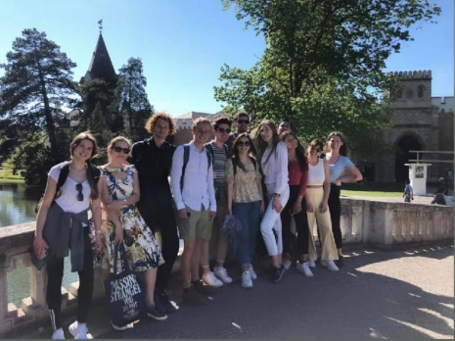
These are my favourite memories and places from the whole semester. When it was a bit warmer, we organized several meetings in these parks: Setagaya Park, Türkenschanzpark next to BOKU and Kurpark Oberlaa. We also visited several museums (Albertina Modern, Vienna Museum of Natural History, Museo della Tecnica, Haus der Musik) but my favourite was the Museum der Illusionen, which was very interesting and interactive. For sunsets the most beautiful place is the Dunauinsel, we organise many picnics here with other Erasmus+ students. And from the Kahlenberg hill you have a wonderful view of the city.
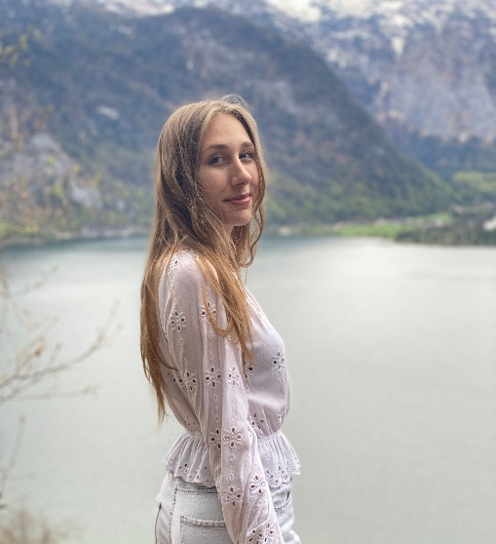
But we have also been to several places outside of Vienna: Hallstatt is the most beautiful small town in Austria. It is surrounded by a lake, has many hiking trails and a salt mine. Baden is close to Vienna, a very quiet and peaceful town, with the Beethovenhaus and a park where you can go hiking. Laxenburg's attractions include a huge palace and a wonderful park with a boating lake, we also went down to the ski slopes of Semmering to ski once
If you've ever thought of applying for an Erasmus+ semester -> go for it!
It's a great adventure, you can make lots of new friends, learn about new cultures, be independent, learn and grow.

